ABX Stewardship

Locating patients with medications for review

- Open your patient list (or whichever status board option you typically choose)

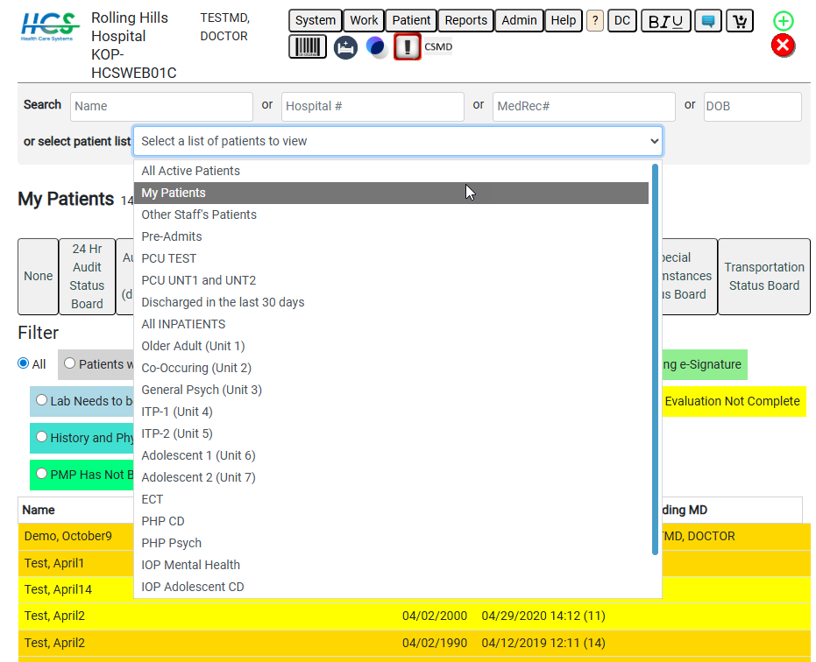

- Click the checkbox for “Antibiotic active >48 hrs and Not Reviewed” (Color of filters may vary by location)
  - This will show any patients that need review

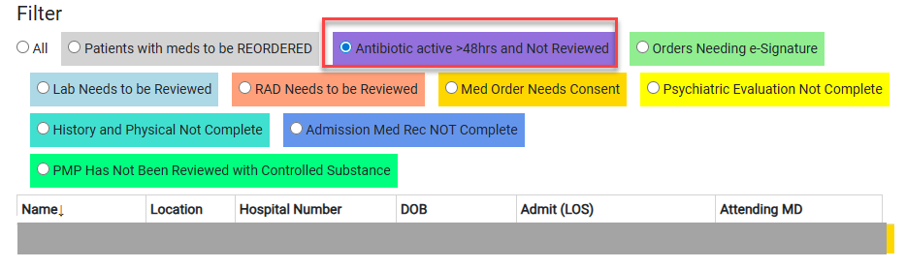

  - When you access the patient that needs the review you will get this pop up (you would still get this pop up if you weren’t using the status board to find the patients)

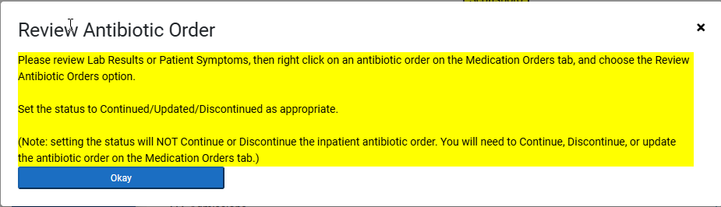

  - The order that needs to be reviewed will be hightlighted purple on the “Medication Orders” tab

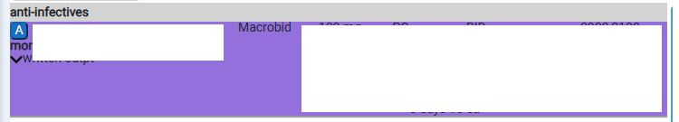

  - “Review Antibiotic Orders”

  - Select your status and add any comments that you may want charted

  - You can also update/ look at these on the “Interventions” tab

